DAY 5: DEVICE MANAGEMENT & CONTROL ENHANCEMENTS

Focus: Advanced Device Management and Control Features

Issues from Previous Day:
- Limited device brand options showing "etc." instead of full list
- Device control not updating actual device status immediately
- No device grouping capabilities
- Scheduler showing "overdue" messages but not updating device states
- Poor device addition flow and validation

Development Activities
Device Brand Enhancement:
OLD CODE: Limited brands with "etc." option
private static final String[] TV_BRANDS = {"Samsung", "Sony", "LG", "etc."};

NEW CODE: Comprehensive brand lists
private static final String[] TV_BRANDS = {
//brands
};

// Enhanced brand selection with custom option
private static String selectDeviceBrand(String deviceType, String[] brands) {
System.out.println("Available " + deviceType + " brands:");
for (int i = 0; i < brands.length; i++) {
System.out.println((i + 1) + ". " + brands[i]);
}
System.out.println((brands.length + 1) + ". Enter custom brand name");

int choice = getValidatedChoice(1, brands.length + 1);
if (choice == brands.length + 1) {
System.out.print("Enter custom brand name: ");
return scanner.nextLine().trim();
}
return brands[choice 1];
}

Device Status Update Fix:
OLD CODE: Scheduler not updating device status
private void executeScheduledTask(TimerTask task) {
System.out.println("Overdue: " + task.getDescription());
// Device status not actually changed
}

NEW CODE: Immediate device status update
private void executeScheduledTask(TimerTask task) {
try {
// Update device status immediately
//logic
);

if (success) {
System.out.println("✓ Device " + task.getDeviceType() + " in " +
task.getRoomName() + " turned " + task.getTargetStatus());

// Update device object status
Gadget device = findDevice(task.getUserEmail(), task.getDeviceType(), task.getRoomName());
if (device != null) {
//logic
}
} else {
System.out.println("✗ Failed to execute scheduled task for " + task.getDeviceType());
}
} catch (Exception e) {
System.err.println("Error executing scheduled task: " + e.getMessage());
}
}

Device Grouping Implementation: Devices grouped for single click automation.

Bug Fixes Implemented:
1. Device Brand Selection Fixed
Removed "etc." option that caused confusion
Added comprehensive brand lists for all device types
Custom brand name entry option for unlisted brands

2. Scheduler Device Status Update Fixed
Immediate device status update when scheduled task executes
Realtime status reflection in device list
Proper error handling for failed status updates

3. Device Control Reliability Improved
Enhanced error handling and retry logic
Status validation before and after control operations
User feedback for successful/failed operations

New Features Added:
1. Device Grouping System
Create device groups for coordinated control
Groupbased automation and scheduling
Bulk device operations (turn all ON/OFF)

2. Enhanced Device Management
Improved device addition flow with validation
Better device search and filtering options
Device usage statistics and history

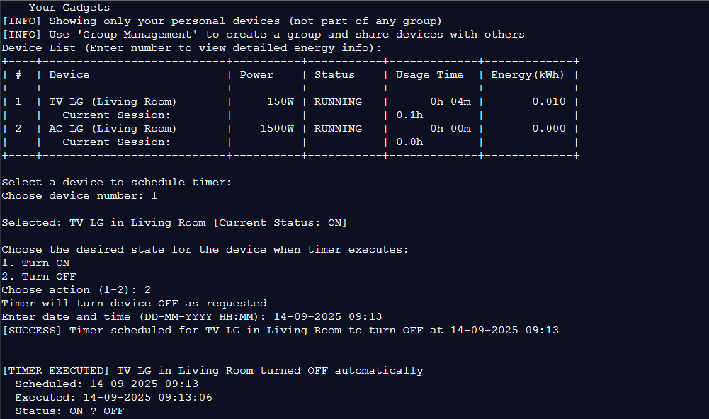

Conclusion Day 5:
Successfully enhanced device management with comprehensive brand support, fixed critical scheduler bugs, and implemented device grouping capabilities. The system now provides reliable device control with immediate status updates.

Key Achievements:
- Fixed device brand selection with comprehensive lists
- Resolved scheduler device status update issues
- Implemented device grouping for bulk operations
- Enhanced device control reliability and error handling

